Chapter 2 Binary Math Homework

2.8

a) The largest positive number one can represent in an 8-bit 2's complement code is:



b) The greatest magnitude negative number one can represent in an 8-bit 2's complement code is:



c) The largest positive number one can represent in n-bit 2's complement code is:



d) The greatest magnitude negative number one can represent in n-bit 2's complement code is:



2.12 If the last two digits of a 2's complement binary number are 00, then the number is a multiple of 4.

2.14

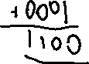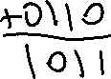

2.18

